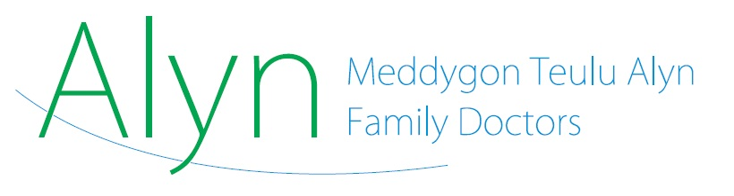

**Private Treatment: Patient Information Leaflet**

You have asked to see a consultant privately, and we have produced an information leaflet because we would like you to be aware of the full implications of opting for private treatment. NHS Wales and Betsi Cadwaladr University Health Board have clear guidelines which cover referrals outside the NHS, and we have to follow them. They include what happens about further investigations and treatment after the initial appointment.

Please be aware that -

If you see a consultant privately, you begin an ‘episode of care’. This includes all investigations or treatment which the consultant decides that you need, including any scans. You - or your insurance company - will therefore have to pay for these.

Private prescriptions from the consultant are included in the ‘episode of care’, and you should expect to pay for them. The episode of care includes all investigations and post-operative monitoring.

We cannot undertake post-operative monitoring (blood tests etc) for operations you may have privately. This is very important, particularly if you choose to have surgery abroad. Some operations have extensive post-operative requirements and you should be clear about the cost and planning of those before undergoing treatment.

If a private consultant gives you a prescription for medication which you still need when your actual treatment is finished, i.e. for on-going care, it is sometimes possible to transfer the prescription back to the NHS. However, if you return to NHS treatment, we reserve the right to switch to an alternative medication if this is more cost-effective. You would of course be able to ask the consultant to continue private prescriptions.

Private consultants sometimes prescribe medication which is outside of its product licence (that is, a condition for which the medication is not designed, even though it may work). We cannot provide prescriptions for medications outside of their product licence. In this case, you would have to continue to obtain prescriptions from the consultant.

Private consultants sometimes prescribe medications, which when prescribed under the NHS, are subject to special ‘shared care agreements’. Commonly used medications which fall into this category include medications for ADHD and rheumatological conditions. These agreements are prescribed in the NHS under a contract between the consultant who starts the medication, the patient, and the GP who will continue the prescribing after the dose has been stabilized. They contain specific requirements for each party. We cannot enter into these agreements with private consultants.

If your private consultant prescribes a shared-care medication, we cannot take over this prescribing and will have to refer you to the standard NHS waiting list for a local consultant to consider.

Please also note that seeing a consultant privately will not mean that you will be seen or treated more quickly on the NHS. If you see a private consultant and then subsequently request to transfer your care back to the NHS, NHS rules require that you be referred to the start of the NHS waiting list at that point.

If you would like any more information, or any clarification, please contact the surgery.